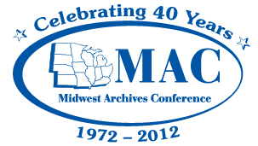

Insert date

Insert name
Insert address/contact information

Dear :

On behalf of the Midwest Archives Conference Program Committee, we are very pleased that you have accepted our invitation to be the Plenary Speaker at our 20___ Annual Meeting, to be held April at the [insert hotel, city/state]. The program committee is delighted you have agreed to speak and believes that the membership will enjoy hearing from you. This letter will confirm the terms of your engagement as Plenary Speaker.

You have agreed to present a Plenary Speech tentatively entitled “ .” At present, your Plenary Speech is scheduled for Thursday, April at p.m.

The Midwest Archives Conference is pleased to provide you with the following compensation for your services as Plenary Speaker:

Honorarium: $ + reimbursement for parking during the meeting

You also agree that the Midwest Archives Conference may use your name, brief biography, and photograph in print and on its website to publicize your talk and the meeting.

Please provide your parking receipt and we will reimburse your parking and pay your honorarium following the conclusion of the meeting.

If these terms are acceptable, please sign one copy of this letter and return it to me and retain a second copy for your records.

We very much look forward to your speech!

Sincerely,

Print president’s name here
President
Midwest Archives Conference
Insert address and contact information

Agreed and accepted:

Print speaker’s name here

Date

